**National University of Computer and Emerging Sciences**



**Laboratory Exercise 02**

*for*

# Web Programming

# Spring 2024

**FAST School of Computer Science**

# LABORATORY OUTCOMES

The practical/exercises in this section are psychomotor domain Learning Outcomes (i.e. subcomponents of the COs), to be developed and assessed to lead to the attainment of the competency.

This Course is designed to take the students full adventure of “**Full Stack Web Development**.”

**Today’s Agenda**

Module 1: Introduction to Cascading Style Sheet (CSS).

Module 2: Differentiation between Inline, Internal, and External CSS

Module 3: Selectors in CSS (Basics, Pseudo, Manual)

Module 4: Image Selectors and Styling

Module 5: Block Level Styling

Module 6: Button Styling and UI

Module 7: Shadow Properties in CSS

Module 8: Transformations in CSS

Module 9: Transitions in CSS

Module 10: Animations in CSS

## Module 1: Introduction to Cascading Style Sheet (CSS).

### 1. What is CSS?

* CSS stands for Cascading Style Sheets
* CSS describes how HTML elements are to be displayed on screen, paper, or in other media
* CSS saves a lot of work. It can control the layout of multiple web pages all at once.

### 2. Why Use CSS?

CSS is used to define styles for your web pages, including the design, layout and variations in display for different devices and screen sizes.

### 3. CSS Syntax

A CSS rule consists of a selector and a declaration block.

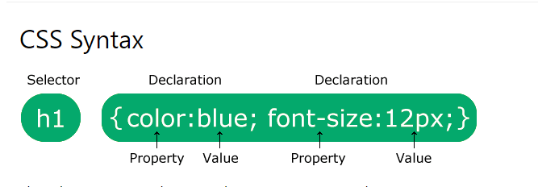

### **Experiment 1.**

### Using this code snippet see the output in your browser.

#### Code Snippet:

<!DOCTYPE html>

<html>

<body>

<h1 style="color:blue;text-align:center;">This is a heading</h1>

<p style="color:red;">This is a paragraph.</p>

</body>

</html>

#### Output:

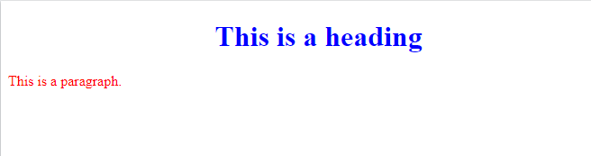

## Module 2: Differentiation between Inline, Internal, and External CSS

**There are three ways of inserting a style sheet:**

1. External CSS
2. Internal CSS
3. Inline CSS

### Inline CSS

An inline style may be used to apply a unique style for a single element.

To use inline styles, add the style attribute to the relevant element. The style attribute can contain any CSS property.

#### Code Snippet:

<!DOCTYPE html>

<html>

<body>

<h1 style="color:blue;text-align:center;">This is a heading</h1>

<p style="color:red;">This is a paragraph.</p>

</body>

</html>

#### Output:



### Internal CSS

An internal style sheet may be used if one single HTML page has a unique style.

The internal style is defined inside the <style> element, inside the head section.

#### Code Snippet:

<!DOCTYPE html>

<html>

<head>

<style>

body {

background-color: linen;

}

h1 {

color: maroon;

margin-left: 40px;

}

</style>

</head>

<body>

<h1>This is a heading</h1>

<p>This is a paragraph. </p>

</body>

</html>

#### Output:

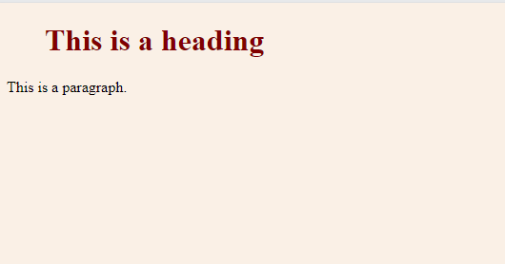

### External CSS

With an external style sheet, you can change the look of an entire website by changing just one file!

Each HTML page must include a reference to the external style sheet file inside the <link> element, inside the head section.

#### Code Snippet:

<!DOCTYPE html>  
<html>  
<head>  
<link rel="stylesheet" href="mystyle.css">

</head>  
<body>  
  
<h1>This is a heading</h1>  
<p>This is a paragraph.</p>  
  
</body>  
</html>

"mystyle.css"

body {  
  background-color: lightblue;  
}  
  
h1 {  
  color: navy;  
  margin-left: 20px;  
}

### **Experiment 2.**

Using your editor implement this External CSS files.

**Pro-Tip:**

Cascading Order:

1. Inline style (inside an HTML element)
2. External and internal style sheets (in the head section)
3. Browser default

## Module 3: Selectors in CSS (Basics, Pseudo, Manual)

The element selector selects HTML elements based on the element name.

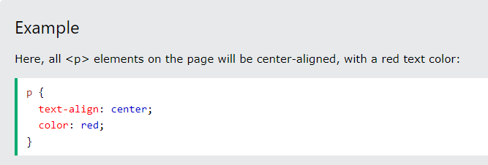

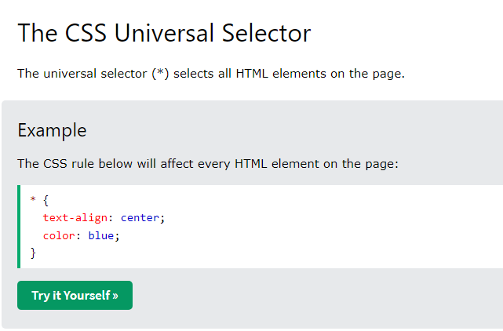

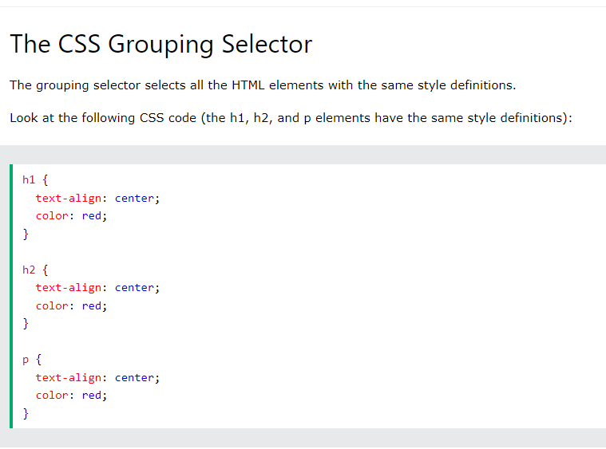

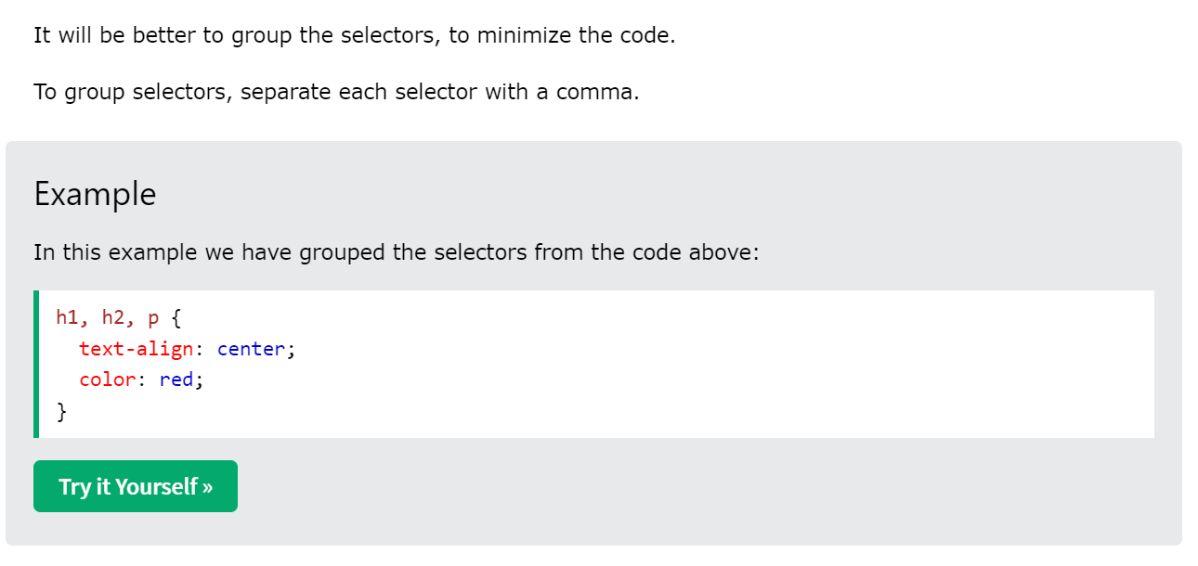

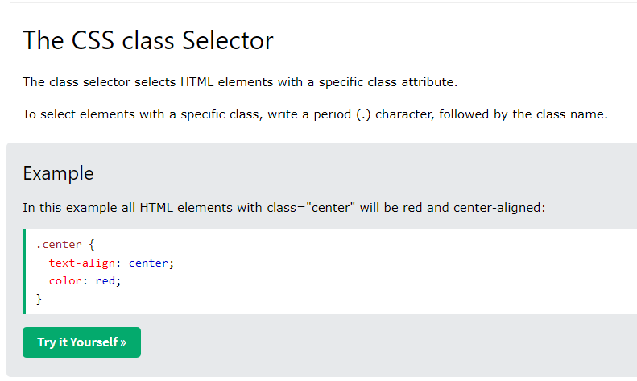

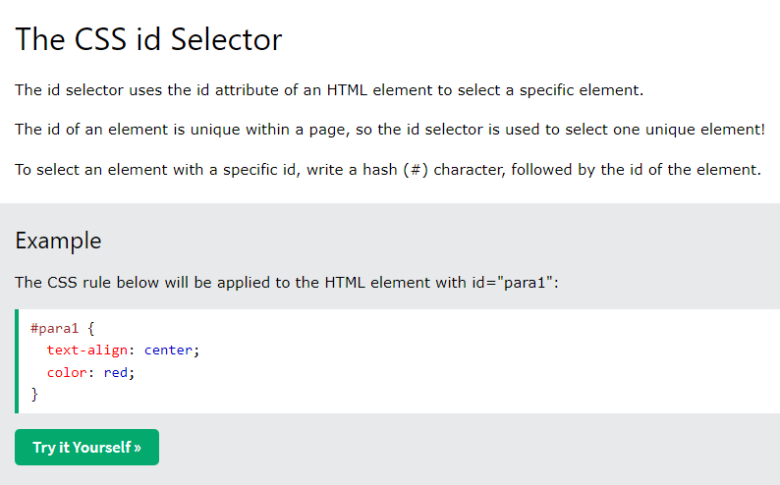

### Summary

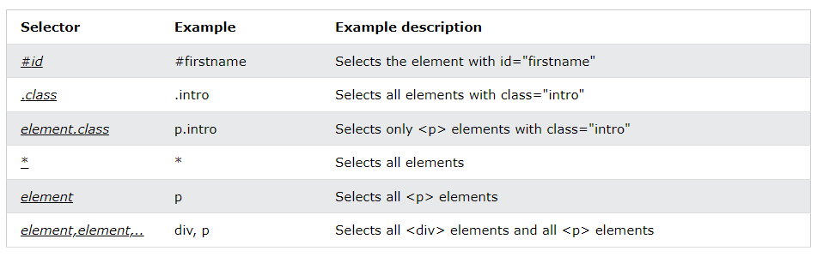

### **Experiment 3.**

Practice Each Selector at this given link:

<https://www.w3schools.com/css/css_selectors.asp>

## Module 4: Image Selectors and Styling

It is recommended to learn the image selectors and styling.

<https://www.w3schools.com/css/css3_images.asp>

## Module 5: Block Level Styling

## 

In CSS, the term "box model" is used when talking about design and layout.

The CSS box model is essentially a box that wraps around every HTML element. It consists of: margins, borders, padding, and the actual content. The image below illustrates the box model:

## 

Explanation of the different parts:

* Content - The content of the box, where text and images appear
* Padding - Clears an area around the content. The padding is transparent
* Border - A border that goes around the padding and content
* Margin - Clears an area outside the border. The margin is transparent

### **Experiment 4.**

Check the output of this code snippet in to your browser, and change the left padding to 50px.

#### Code Snippet:

<!DOCTYPE html>

<html>

<head>

<style>

div {

background-color: lightgrey;

width: 300px;

border: 15px solid green, 15px solid green;

padding: 50px;

margin: 20px;

}

</style>

</head>

<body>

<h2>Demonstrating the Box Model</h2>

<p>The CSS box model is essentially a box that wraps around every HTML element. It consists of: borders, padding, margins, and the actual content.</p>

<div>This text is the content of the box. We have added a 50px padding, 20px margin and a 15px green border. Ut enim ad minim veniam, quis nostrud exercitation ullamco laboris nisi ut aliquip ex ea commodo consequat. Duis aute irure dolor in reprehenderit in voluptate velit esse cillum dolore eu fugiat nulla pariatur. Excepteur sint occaecat cupidatat non proident, sunt in culpa qui officia deserunt mollit anim id est laborum.</div>

</body>

</html>

It is recommended to learn more about “**Margins**” and “**Padding**” here.

<https://www.w3schools.com/css/css_margin.asp>

<https://www.w3schools.com/css/css_padding.asp>

## Module 6: Shadow Properties in CSS

With CSS you can add shadow to text and to elements.

In its simplest use, you only specify the horizontal shadow (2px) and the vertical shadow (2px):

* text-shadow
* box-shadow

In its simplest use, you only specify the horizontal shadow (2px) and the vertical shadow (2px):

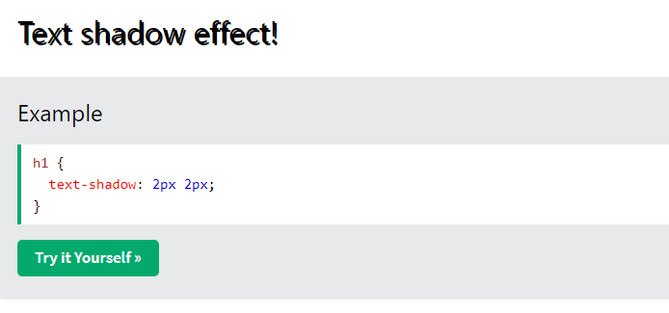

It is recommended to learn more about “**Text Shadows**” and “**Box Shadows**” here.

<https://www.w3schools.com/css/css3_shadows.asp>

<https://www.w3schools.com/css/css3_shadows_box.asp>

## Module 7: Button Styling and UI

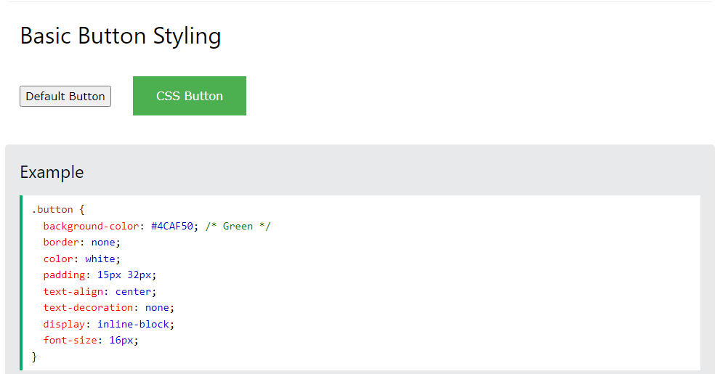

### **Experiment 5. Use this link to practice more about Buttons.**

<https://www.w3schools.com/css/css3_buttons.asp>

## Module 8: Transformations in CSS

CSS 2D Transforms

CSS transforms allow you to move, rotate, scale, and skew elements.

With the CSS transform property you can use the following 2D transformation methods:

* translate()
* rotate()
* scaleX()
* scaleY()
* scale()
* skewX()
* skewY()
* skew()
* matrix()

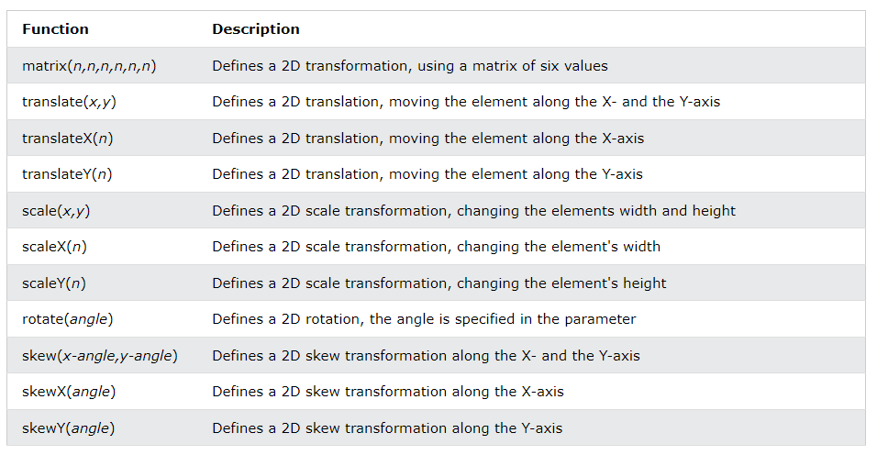

### **Experiment 6. Use this link to practice more about 2-D Transformations.**

<https://www.w3schools.com/css/css3_2dtransforms.asp>

## Module 9: Transitions in CSS

CSS transitions allows you to change property values smoothly, over a given duration.

**How to Use CSS Transitions?**

* To create a transition effect, you must specify two things:
* the CSS property you want to add an effect to the duration of the effect

**Example:**

div:hover {  
  width: 300px;  
}

The transition-timing-function property specifies the speed curve of the transition effect.

The transition-timing-function property can have the following values:

ease - specifies a transition effect with a slow start, then fast, then end slowly (this is default)

linear - specifies a transition effect with the same speed from start to end

ease-in - specifies a transition effect with a slow start

ease-out - specifies a transition effect with a slow end

ease-in-out - specifies a transition effect with a slow start and end

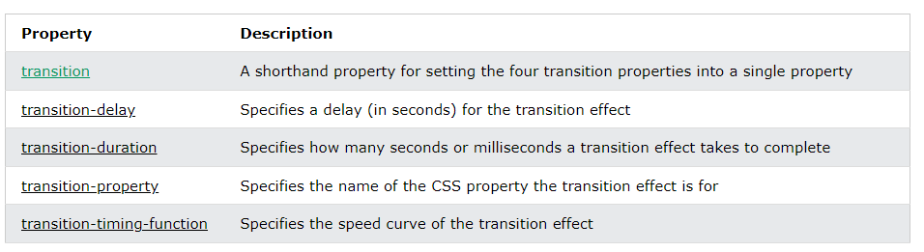

### **Experiment 7.**

### Using this code snippet see the output in your browser.

#### Code Snippet:

<!DOCTYPE html>

<html>

<head>

<style>

div {

width: 100px;

height: 100px;

background: red;

transition: width 2s;

}

#div1 {transition-timing-function: linear;}

#div2 {transition-timing-function: ease;}

#div3 {transition-timing-function: ease-in;}

#div4 {transition-timing-function: ease-out;}

#div5 {transition-timing-function: ease-in-out;}

div:hover {

width: 300px;

}

</style>

</head>

<body>

<h1>The transition-timing-function Property</h1>

<p>Hover over the div elements below, to see the different speed curves:</p>

<div id="div1">linear</div><br>

<div id="div2">ease</div><br>

<div id="div3">ease-in</div><br>

<div id="div4">ease-out</div><br>

<div id="div5">ease-in-out</div><br>

</body>

</html>

## Module 10: Animations in CSS

CSS allows animation of HTML elements without using JavaScript or Flash!

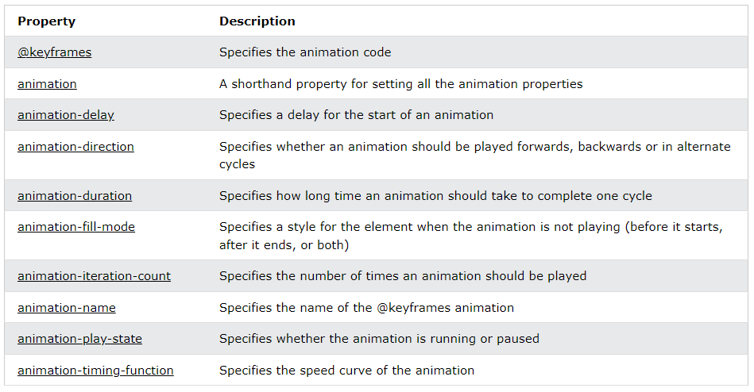

### **Experiment 8. Use this link to practice more about Animations in CSS**

<https://www.w3schools.com/css/css3_animations.asp>

## More Recommended Topis

1. Positions
2. Forms UI
3. Fonts Styles and Sizes
4. Dropdowns

**Visit Link to Practice More About Forms:**

<https://www.w3schools.com/html/html_forms.asp>

**You are done with your exercise(s), make your submission on Classroom.**

**BEST WISHES**

**References**

CSS tutorial. (n.d.). Retrieved February 15, 2022, from https://www.w3schools.com/css/default.asp